Protecting our Public Water System

**Backflow Prevention and Cross-Connection Control**

**What is a Cross Connection?**

A cross connection is a point in a plumbing system where the potable water supply is con nected to a non-potable source. Briefly, a cross connection exists whenever the drinking water system is or could be connected to any non potable source (plumbing fixture, equipment used in any plumbing system). Pollutants or contami nants can enter the safe drinking water system through uncontrolled cross connections when backflow occurs.

**What is backflow?**

Backflow is the unwanted flow of non-potable substances back into the consumer’s plumbing system and/or public water system (i.e., drinking water).

There are two types of backflow: backsiphonage and backpressure.

* Backsiphonage is caused by a negative pressure in the supply line to a facility or plumbing fixture. Backsiphonage may occur during waterline breaks, when repairs are made to the waterlines, when shutting off the water supply, etc.
* Backpressure can occur when the potable water supply is connected to another system operated at a higher pressure or has the ability to create pressure. Principal causes are booster pumps, pressure vessels and elevated plumbing.

**What can I do?**

• Be aware of and eliminate cross-connections. • Maintain air gaps. Do not submerge hoses or place them where they could become submerged. • Use hose bib vacuum breakers on fixtures (hose connections in the basement, laundry room and outside). • Install approved, testable backflow preventers on lawn irrigation systems. • Do not create a connection between an auxiliary water system (well, cistern, body of water) and the water supply plumbing.

**What are some common backflow hazards that threaten the homeowner and other consumers?**

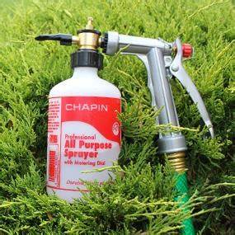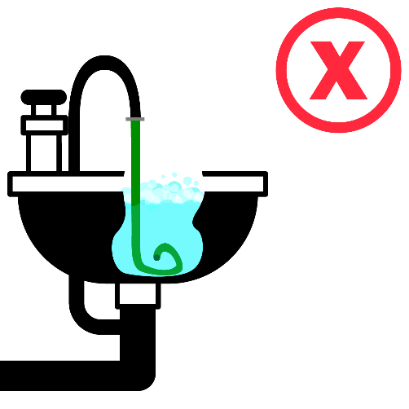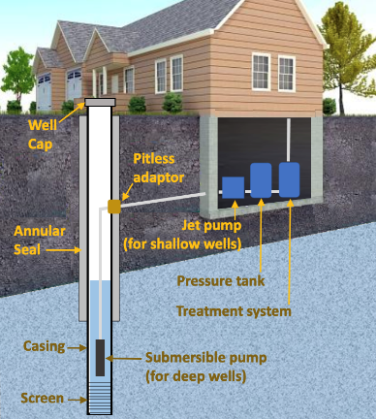

* Hose connections to chemical solution aspirators to feed lawn and shrub herbicides, pesticides or fertilizers.

• Lawn irrigation systems.

• Chemically treated heating systems.

• Swimming pools, hot tubs, spas.

• Private and/or non-potable water supplies located on the property.

• Water-operated sump drain devices.

• Feed lots/livestock holding areas or barnyards fed through pipes or hoses from your water

supply plumbing.

**What must be done to protect the public water system?**

The public water supplier must determine potential and actual hazards. If a hazard exists at a customer’s public water supply service connection, the customer will be required to install and maintain an appropriate backflow preventer* at the meter and/or at the source of the hazard. *Check with your water supplier to verify which backflow preventer is required before purchase or installation.

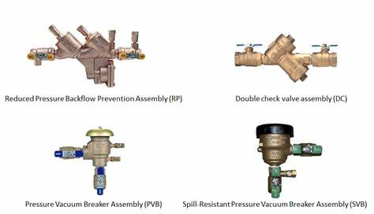

If you have any concerns about cross connections or questions about backflow preventers, please contact

## Contact Information

Carlos R. Gonzalez

Phone: 661-578-0944  
Email: cross03550@gmail.com  
Web: <https://crosscontrol03550.com/>